Lagged cross-correlation: AUDUSD and USDCAD
Method 12 / daily log returns / K_max=10 / Alpari D1 full available history

Study setup
Logical pair: AUDUSD , USDCAD
Broker symbols: AUDUSD_i , USDCAD_i
Snapshot: 2026-11-03_majors_alpari_D1
Timeframe: D1
Matched return window: 1999-01-05 to 2026-11-02 (UTC bar dates)
Matched return count n: 7204
Dropped unfinished last bar dated 2026-11-03 UTC after a tick-volume check against the prior complete day.
Lag definition: rho_X->Y(k) = Corr(x_t, y_{t+k}) on matched D1 bars
K_max = 10; headline lag k = 1 (both directions)
Complete matched rows (Excel): AUDUSD-USDCAD_Lagged_D1.xlsx
Complete matched rows (HTML table): AUDUSD-USDCAD_Lagged_D1_data.html

Method carried forward
Lagged cross-correlation measures Pearson correlation between matched daily log returns of close, ln(close_t / close_t-1), after shifting one series forward by k bars on the matched panel. Quotes are not inverted. rho_{X->Y}(k) = Corr(x_t, y_{t+k}) with n_k = n - k. K_max = 10 is fixed before estimation. The headline is the pre-specified lag k = 1 in both directions. k = 0 is the same-bar side check. The lag inside 1..10 with the largest absolute rho is stored as a descriptive column only; it is not a selected result. This is a linear screen, not proof of forecast edge, economic cause, or a trading signal.

Results (headline k=1)
rho_AUDUSD->USDCAD(1): 0.023202 (n=7203)
95% Fisher interval AUDUSD->USDCAD: [0.000108, 0.046272]
rho_USDCAD->AUDUSD(1): 0.007845 (n=7203)
95% Fisher interval USDCAD->AUDUSD: [-0.015252, 0.030934]
Same-bar rho(k=0): -0.647362
Largest |rho| among k=1..10 (descriptive only, not selected): AUDUSD->USDCAD k=4 rho=-0.032732; USDCAD->AUDUSD k=4 rho=-0.046499

CCF table
k | rho_AUDUSD_to_USDCAD | n_AUDUSD_to_USDCAD | rho_USDCAD_to_AUDUSD | n_USDCAD_to_AUDUSD
0 | -0.64736168 | 7204 | -0.64736168 | 7204
1 | 0.02320232 | 7203 | 0.00784521 | 7203
2 | -0.001896 | 7202 | -0.01809416 | 7202
3 | 0.0131753 | 7201 | -0.00535847 | 7201
4 | -0.03273247 | 7200 | -0.04649895 | 7200
5 | 0.01248413 | 7199 | 0.03153482 | 7199
6 | 0.01700791 | 7198 | 0.02152134 | 7198
7 | 0.00496174 | 7197 | -0.01306568 | 7197
8 | -0.02181901 | 7196 | -0.03315364 | 7196
9 | 0.02542062 | 7195 | 0.03841326 | 7195
10 | -0.01646814 | 7194 | -0.00682591 | 7194

Conclusion
At the pre-specified lag k=1 for AUDUSD and USDCAD, rho_{AUDUSD->USDCAD}(1) = 0.0232 (n=7203) and rho_{USDCAD->AUDUSD}(1) = 0.0078 (n=7203). Same-bar rho(k=0) = -0.6474. Largest |rho| among k=1..10 is descriptive only: AUDUSD->USDCAD at k=4 (-0.0327); USDCAD->AUDUSD at k=4 (-0.0465). This is a linear screen, not forecast proof or a trading signal.

Charts
Daily closes

Daily log returns

CCF both directions k=0..10
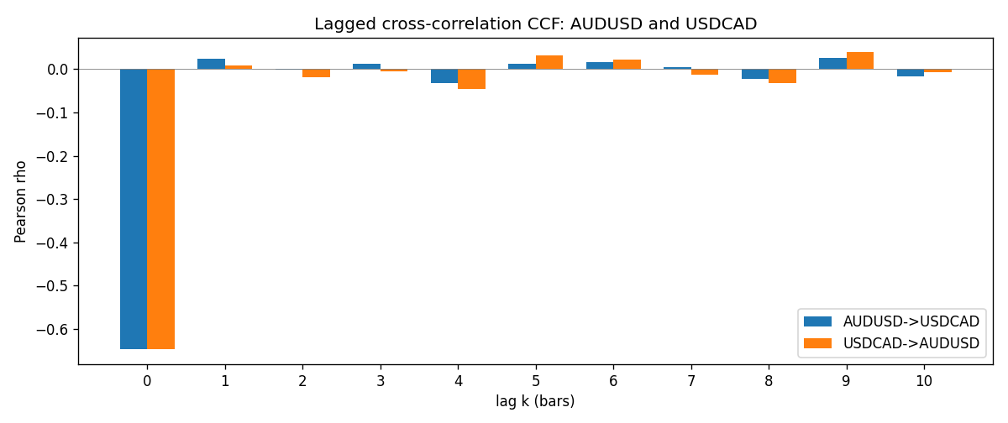

Data report
Every matched row is stored in the sibling Excel workbook named AUDUSD-USDCAD_Lagged_D1.xlsx (sheet matched_rows). The CCF sheet holds rho(k) for k=0..10. Embedding all rows as a Word table is impractical; the Word file holds column summaries and the first and last 15 rows.
Columns: time, AUDUSD_open, USDCAD_open, AUDUSD_high, USDCAD_high, AUDUSD_low, USDCAD_low, AUDUSD_close, USDCAD_close, AUDUSD_tick_volume, USDCAD_tick_volume, AUDUSD_spread, USDCAD_spread, AUDUSD_real_volume, USDCAD_real_volume, AUDUSD_log_return, USDCAD_log_return
Column summaries (matched calculation rows)
column | count | mean | std | min | 25% | 50% | 75% | max
AUDUSD_open | 7204 | 0.75193151 | 0.13526075 | 0.4785 | 0.6610425 | 0.731405 | 0.8086175 | 1.10284
USDCAD_open | 7204 | 1.2670146 | 0.16899756 | 0.9168 | 1.118975 | 1.298545 | 1.372225 | 1.6183
AUDUSD_high | 7204 | 0.7559812 | 0.13582551 | 0.4878 | 0.6647 | 0.734785 | 0.81467 | 1.10795
USDCAD_high | 7204 | 1.2719163 | 0.16895637 | 0.9336 | 1.123375 | 1.30394 | 1.3767575 | 1.619
AUDUSD_low | 7204 | 0.74787477 | 0.13457623 | 0.4775 | 0.6577 | 0.727495 | 0.8042 | 1.0975
USDCAD_low | 7204 | 1.2624553 | 0.16903522 | 0.9056 | 1.11435 | 1.293585 | 1.3678925 | 1.6102
AUDUSD_close | 7204 | 0.75197934 | 0.13524694 | 0.4786 | 0.6611975 | 0.731695 | 0.808875 | 1.10169
USDCAD_close | 7204 | 1.2670334 | 0.16897258 | 0.916 | 1.11848 | 1.298615 | 1.372515 | 1.6137
AUDUSD_tick_volume | 7204 | 77316.143 | 138115.43 | 109 | 5421.75 | 43310.5 | 71296.75 | 1234623
USDCAD_tick_volume | 7204 | 80846.476 | 147183.52 | 56 | 5511.25 | 40857 | 71531.75 | 1410818
AUDUSD_spread | 7204 | 30.823709 | 16.885829 | 0 | 13 | 30 | 50 | 50
USDCAD_spread | 7204 | 23.505275 | 18.28107 | 0 | 9 | 17 | 40 | 60
AUDUSD_real_volume | 7204 | 5.2399076e+09 | 1.2535442e+11 | 0 | 0 | 0 | 0 | 3.811512e+12
USDCAD_real_volume | 7204 | 1.8332738e+10 | 9.6584767e+10 | 0 | 0 | 0 | 0 | 2.5751613e+12
AUDUSD_log_return | 7204 | 2.007e-05 | 0.0075444 | -0.08602525 | -0.00386183 | 0.00027895 | 0.00414528 | 0.0806166
USDCAD_log_return | 7204 | -1.21e-05 | 0.00514438 | -0.03859748 | -0.00283637 | 4.97e-05 | 0.00272781 | 0.03436319
First 15 matched rows (selected columns)
time | AUDUSD_close | USDCAD_close | AUDUSD_log_return | USDCAD_log_return
1999-01-05 | 0.6215 | 1.5123 | -0.00080418179 | -0.010131666
1999-01-06 | 0.6289 | 1.5118 | 0.011836351 | -0.0003306769
1999-01-07 | 0.6345 | 1.5141 | 0.0088650256 | 0.0015202092
1999-01-08 | 0.6347 | 1.511 | 0.00031515916 | -0.0020495197
1999-01-11 | 0.6393 | 1.5057 | 0.0072213815 | -0.0035137769
1999-01-12 | 0.6362 | 1.5157 | -0.0048608485 | 0.0066194721
1999-01-13 | 0.6312 | 1.5226 | -0.0078902098 | 0.0045420214
1999-01-14 | 0.6295 | 1.5332 | -0.002696916 | 0.0069376546
1999-01-15 | 0.634 | 1.5245 | 0.007123101 | -0.0056905671
1999-01-18 | 0.6346 | 1.526 | 0.00094592471 | 0.00098344542
1999-01-19 | 0.6392 | 1.5302 | 0.0072225153 | 0.002748513
1999-01-20 | 0.64 | 1.5211 | 0.0012507819 | -0.0059646885
1999-01-21 | 0.6405 | 1.5146 | 0.00078094498 | -0.0042823796
1999-01-22 | 0.6327 | 1.5184 | -0.012252745 | 0.0025057712
1999-01-25 | 0.6302 | 1.5197 | -0.0039591468 | 0.00085579808
Last 15 matched rows (selected columns)
time | AUDUSD_close | USDCAD_close | AUDUSD_log_return | USDCAD_log_return
2026-10-13 | 0.69821 | 1.4214 | 0.0035007712 | -0.0046395653
2026-10-14 | 0.69715 | 1.42356 | -0.0015193215 | 0.0015184751
2026-10-15 | 0.69191 | 1.41843 | -0.0075447063 | -0.0036101503
2026-10-16 | 0.69426 | 1.41357 | 0.0033906408 | -0.0034322068
2026-10-19 | 0.6978 | 1.41091 | 0.0050859986 | -0.0018835331
2026-10-20 | 0.70022 | 1.40569 | 0.0034620426 | -0.0037066008
2026-10-21 | 0.70275 | 1.4045 | 0.0036066384 | -0.00084691787
2026-10-22 | 0.70186 | 1.40081 | -0.0012672558 | -0.0026307268
2026-10-23 | 0.70353 | 1.40085 | 0.0023765656 | 2.85545e-05
2026-10-26 | 0.70128 | 1.40093 | -0.0032032829 | 5.7106554e-05
2026-10-27 | 0.70245 | 1.40449 | 0.0016669876 | 0.0025379458
2026-10-28 | 0.70533 | 1.39911 | 0.0040915541 | -0.0038379274
2026-10-29 | 0.70245 | 1.39895 | -0.0040915541 | -0.00011436495
2026-10-30 | 0.70316 | 1.39751 | 0.0010102376 | -0.0010298736
2026-11-02 | 0.69971 | 1.39837 | -0.0049184984 | 0.00061519094

